|  |  |
| --- | --- |
| Semester | T.E. Semester V – Computer Engineering |
| Subject | Computer Network |
| Subject Professor In-charge | Prof. Amit K. Nerurkar |
| Assisting Teachers | Prof. Amit K. Nerurkar |
| Laboratory | Lab number |

|  |  |
| --- | --- |
| Student Name | Deep Salunkhe |
| Roll Number | 21102A0014 |
| TE Division | A |

**Title:** Study of Networking commands

**Implementation:**

1. **Netstat** (Network Statistics):

- Purpose: Displays network-related information, including active network connections, routing tables, interface statistics, and more.

- Example: Display all listening ports on a Linux system.

Command: netstat -tuln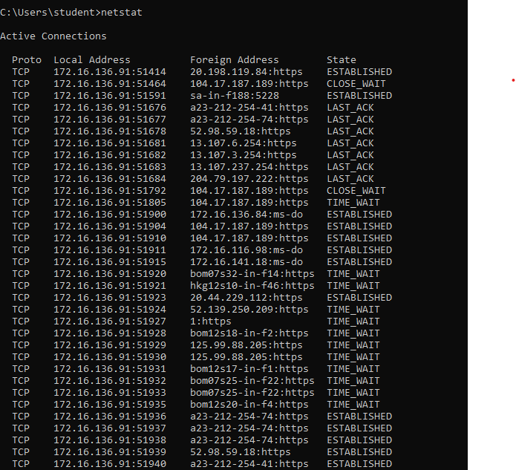

2. **TraceRoute** (Traceroute) :

- Purpose: Traces the route that packets take from one host to another, showing the IP addresses and response times of each hop.

- Example: Trace the route to google.com.

Command: traceroute google.com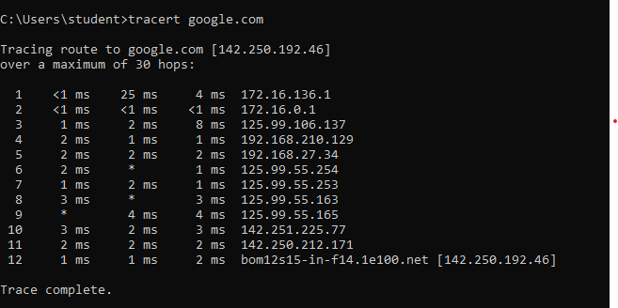

3. **Ifconfig**:

- Purpose: Used to configure and display information about network interfaces on Unix-like systems (Linux, macOS).

- Example: Display network information for the "eth0" interface on a Linux system.

Command: ifconfig

4. **IpConfig**:

- Purpose: Displays or configures IP-related information on Windows systems.

- Example: Display IP configuration information for all interfaces on a Windows system.

Command: ipconfig /all

5. **IpAddr**:

- Purpose: Similar to `ifconfig`, used to show or manipulate IP addresses on Linux systems.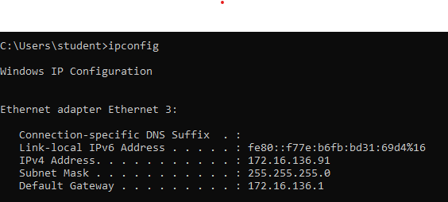

- Example: Display IP address information for all interfaces on a Linux system.

Command: ip addr show

6. **Dig** (Domain Information Groper):

- Purpose: Performs DNS queries to look up DNS records (A, MX, NS, etc.) for domain names.

- Example: Look up the IP address of example.com using Dig.

Command: dig example.com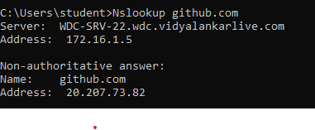

7. **Host**:

- Purpose: Resolves domain names to IP addresses and vice versa.

- Example: Resolve the IP address of google.com using the host command.

Command: host google.com

8. **ARP** (Address Resolution Protocol):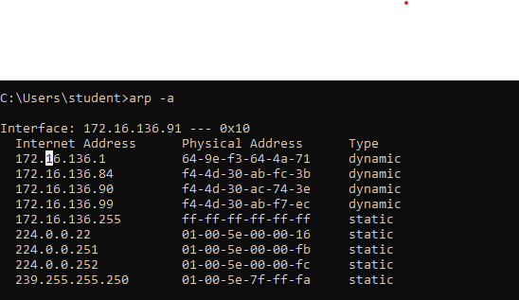

- Purpose: Maps an IP address to a physical MAC address on a local network.

- Example: Display the ARP cache on a Windows system.

Command: arp -a

9. **FTP** (File Transfer Protocol):

- Purpose: A protocol for transferring files between a client and a server over a network.

- Example: Connect to an FTP server and upload a file using FTP.

Command: ftp ftp.example.com

10. **TelNet**:

- Purpose: Allows remote terminal access to a device or server over a network.

- Example: Connect to a remote server with IP address 192.168.1.100 on port 22 (SSH).

Command: telnet 192.168.1.100 22

**Differences between ifconfig , ipconfig, and ip addr:**

- **ifconfig**(Unix/Linux):

- Primarily used on Unix-like systems (Linux, macOS).

- Displays and configures network interfaces.

- **ipconfig** (Windows):

- Specific to Windows.

- Displays and configures IP-related information.

- **ip addr** (Unix/Linux):

- Similar to ipconfig on Windows.

- Provides detailed IP address information on Linux systems.

**End Result:**

**Conclusion:** In summary, these commands are used for various networking tasks such as network configuration, diagnostics, DNS queries, and file transfer. The choice of command depends on your operating system and specific networking needs.